Step by Step create a Jenkins Job

1. Click “New Item” Link

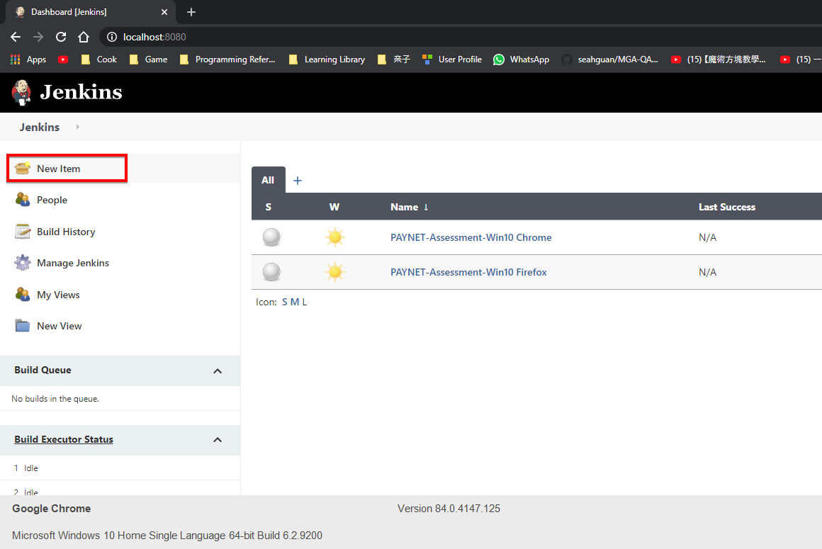

1. Provide Name, then Select “FreeStyle” and Click ok

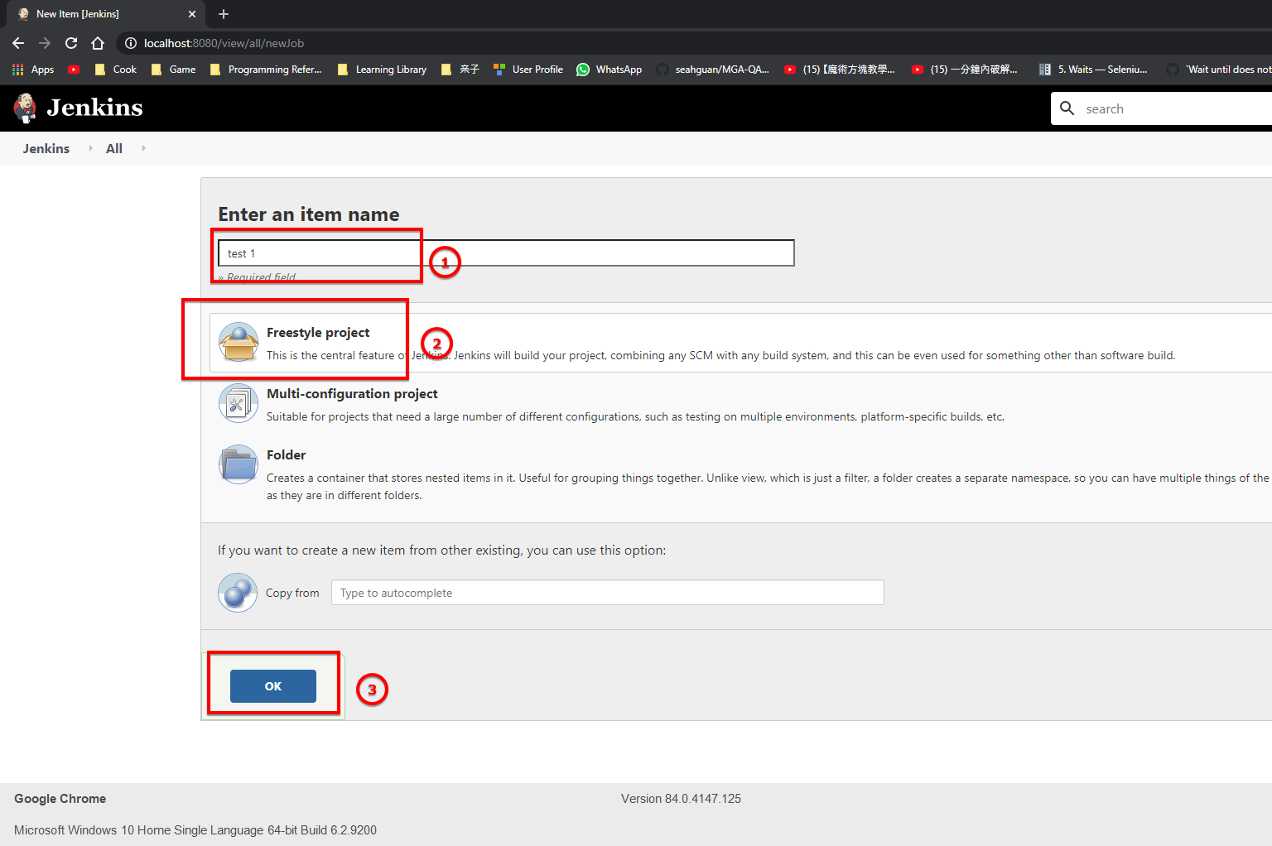

1. Configure the GIT options – Select GIT radio Button

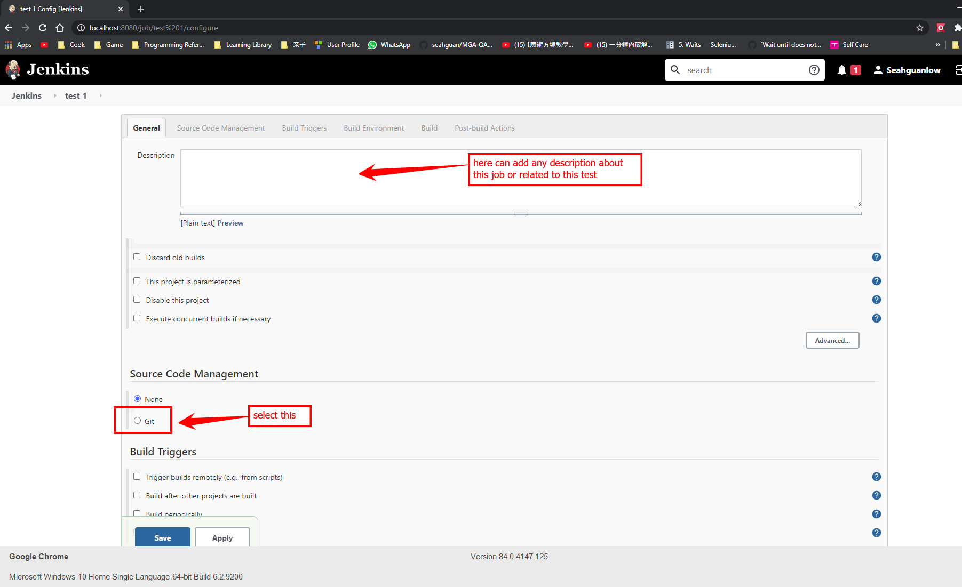

1. Supply the repo URL (clone your repository URL

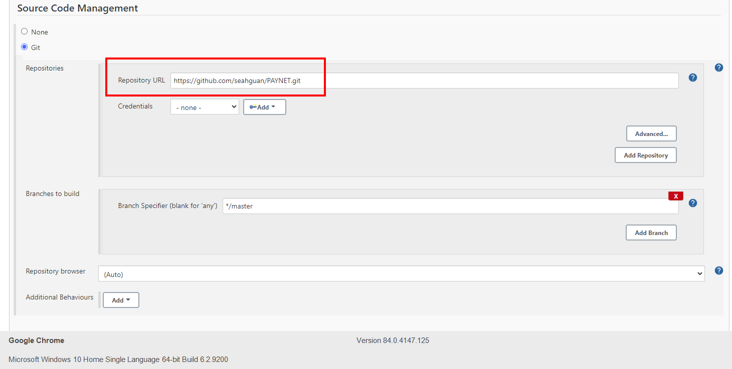

1. Specify a GIT Branch or Master (if you want to use master copy to run)

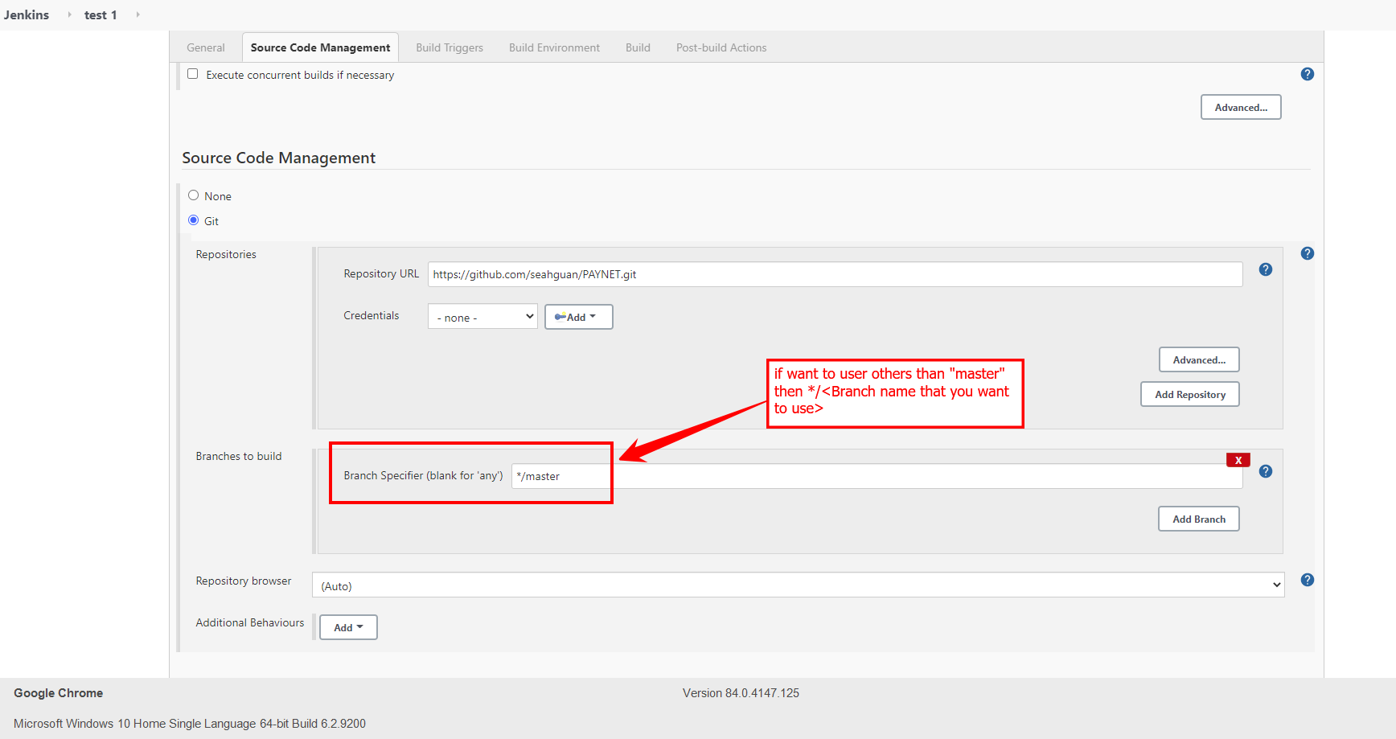

1. Create and select new Jenkins credential (your GIT Repo Credential)

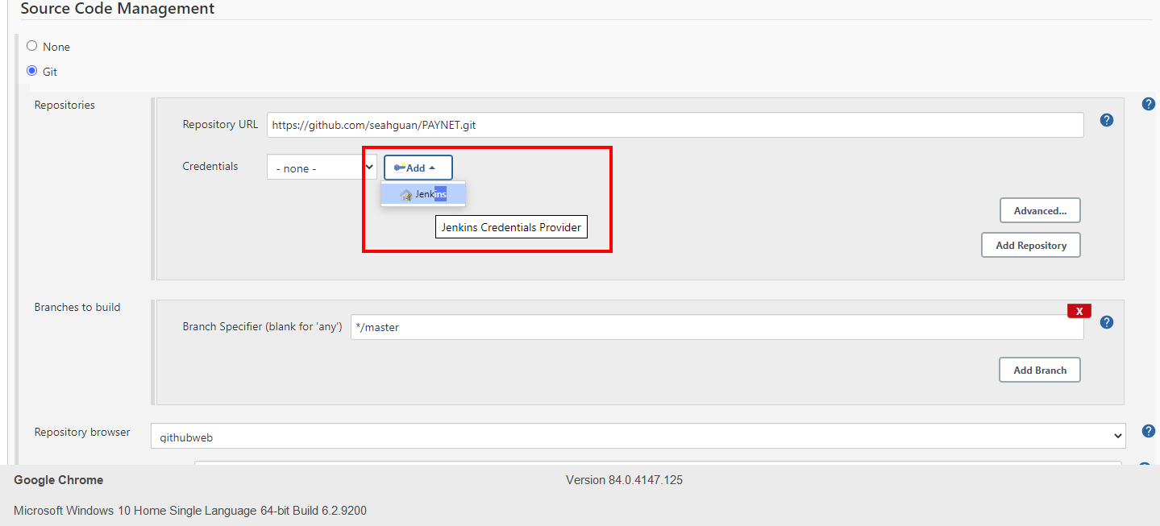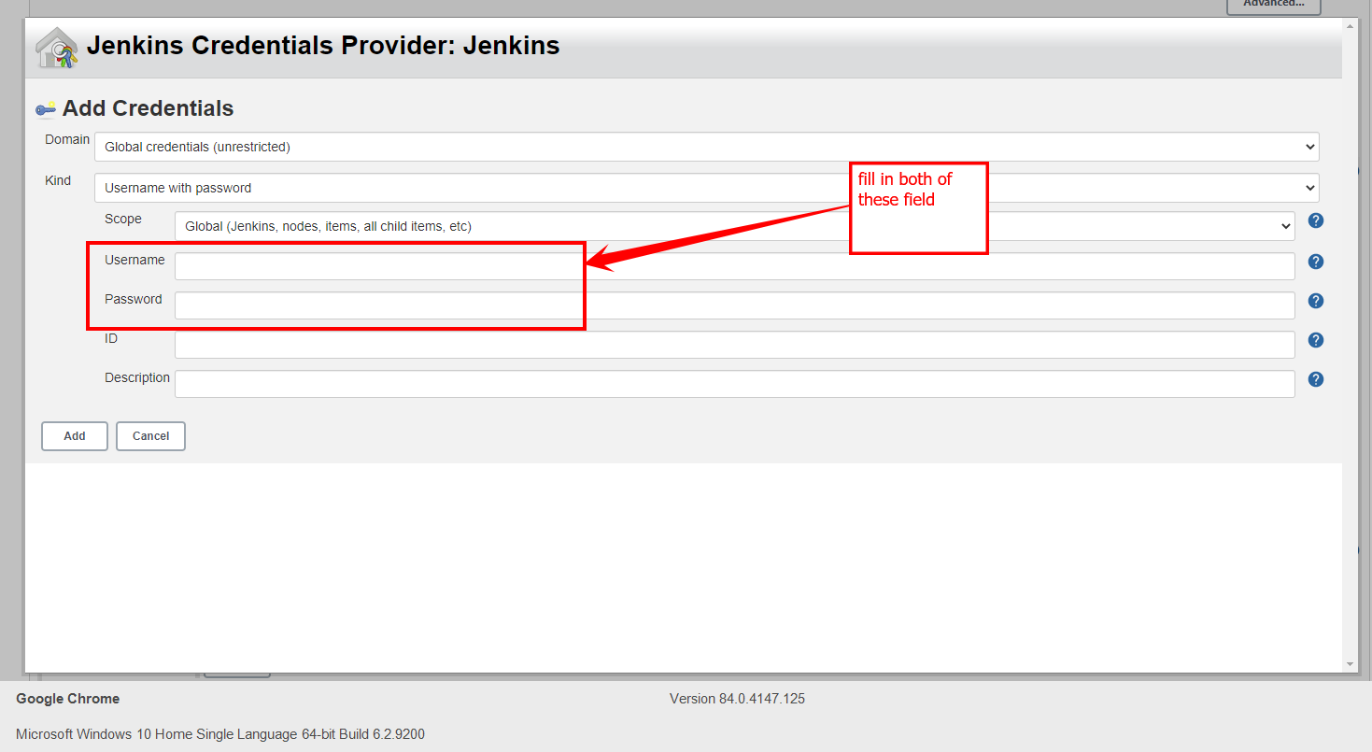

Then click on the add button

Then select the just added git repo credential from here

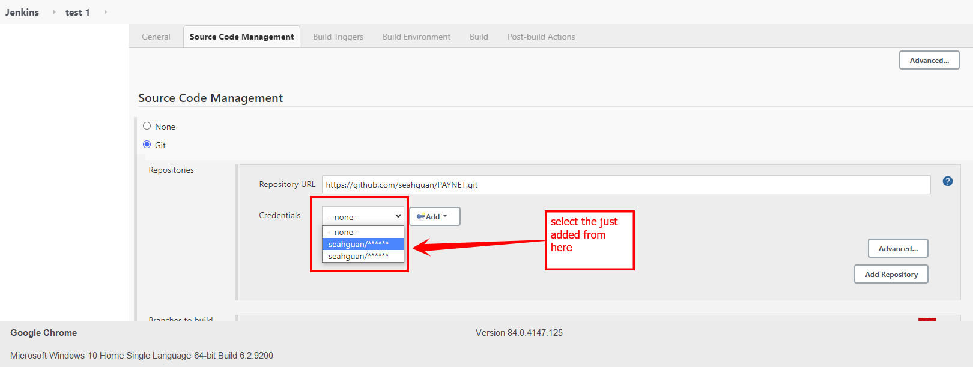

1. Add “Execute Windows Batch Command

Schedule job setting

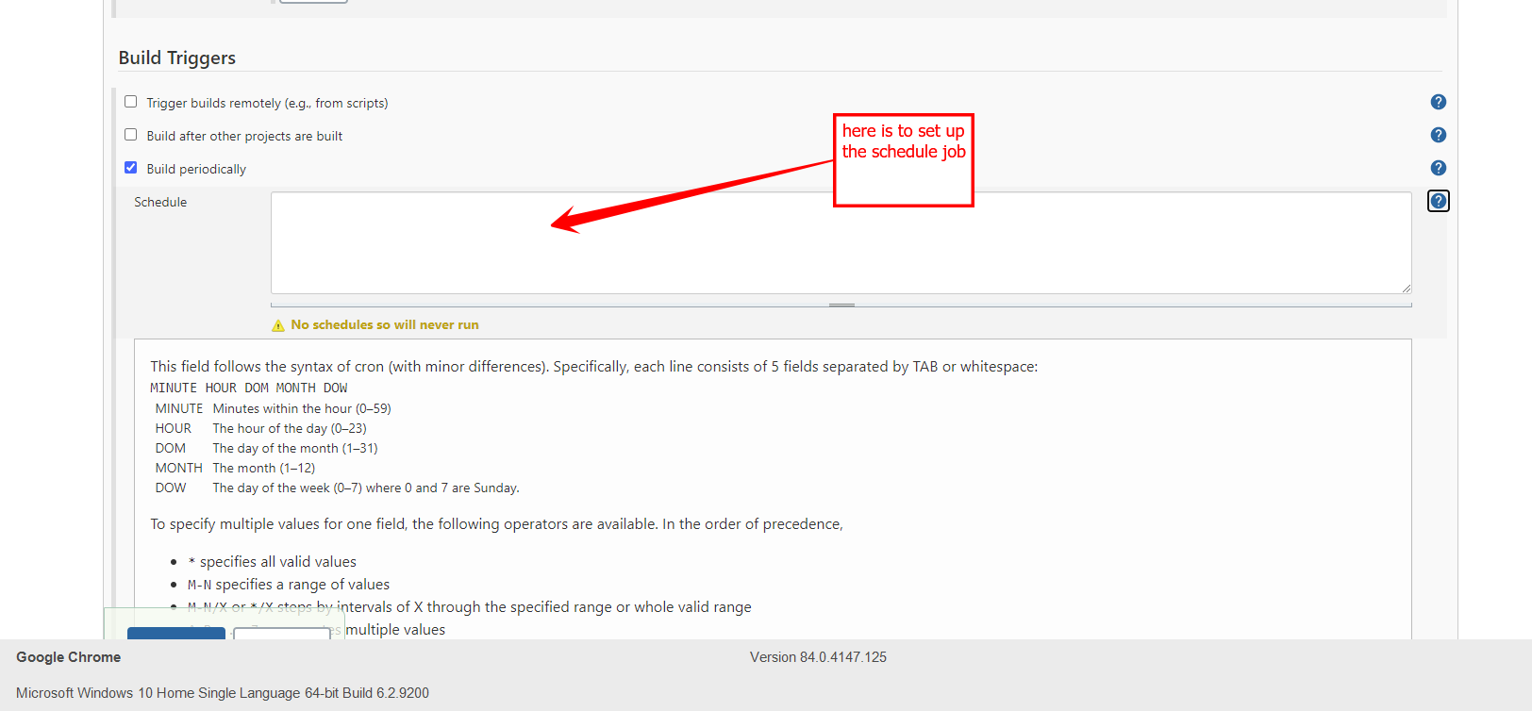

Select this Execute Windows Batch command

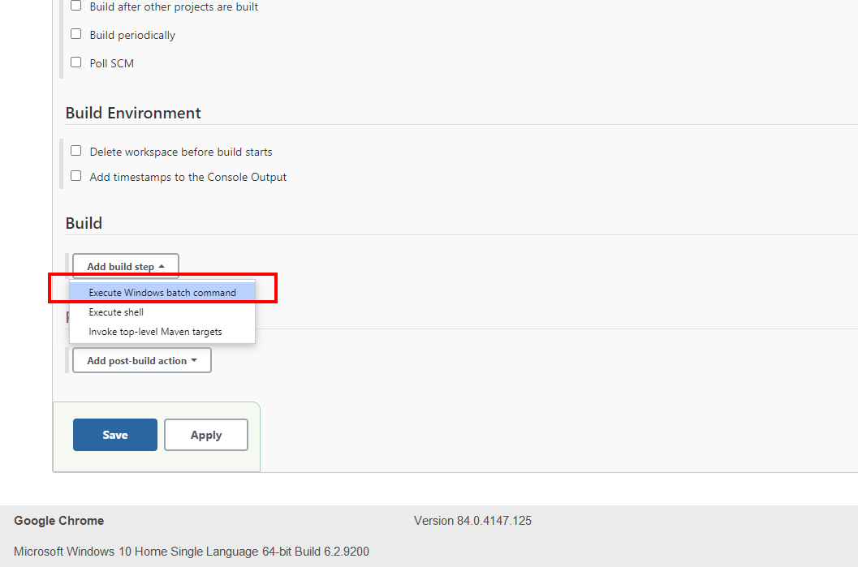

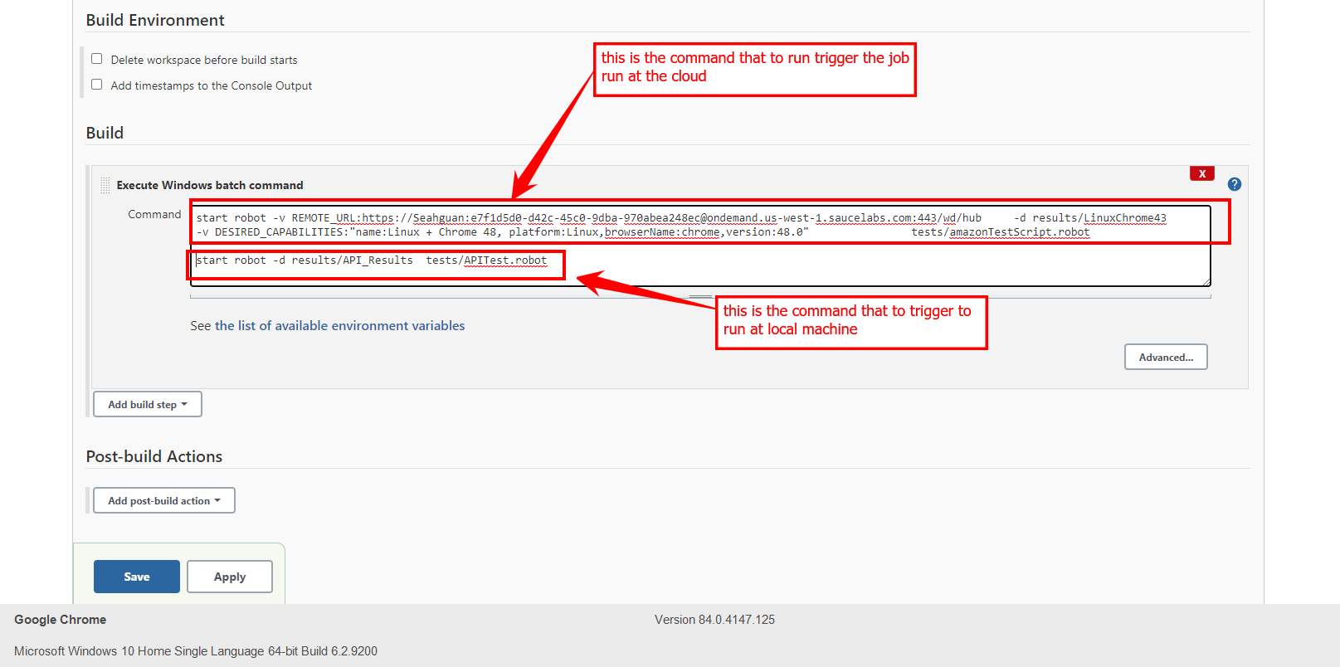

1. Add “Publish robot result” for post build action where to specify the result to store at which location and also the screen shot naming pattern or add the email notification

